Student worksheet answers

7.1 Displacement is change in position with direction

Pages 156–157

Distance and displacement

1 Complete the second column of the table below, showing your understanding of the key terms on the left. Once you have finished, discuss with a peer, recording their understanding in the third column. Finally, check your answers with your teacher or the Student book by using the glossary at the end.

|  |  |  |  |
| --- | --- | --- | --- |
| Key term | My understanding of this word | My peer’s understanding of this word | Actual definition |
| Distance | Students’ answers will vary. | Students’ answers will vary. | How far an object travels over a certain period of time |
| Displacement | Students’ answers will vary. | Students’ answers will vary. | A vector quantity that measures the change in position of an object and its direction over a certain period of time |
| Scalar quantity | Students’ answers will vary. | Students’ answers will vary. | A quantity that only has size (or magnitude) and no direction (e.g. distance) |
| Vector quantity | Students’ answers will vary. | Students’ answers will vary. | A quantity that has size and direction (e.g. velocity, displacement) |

A girl riding her skateboard completed the journey shown by the graph below.

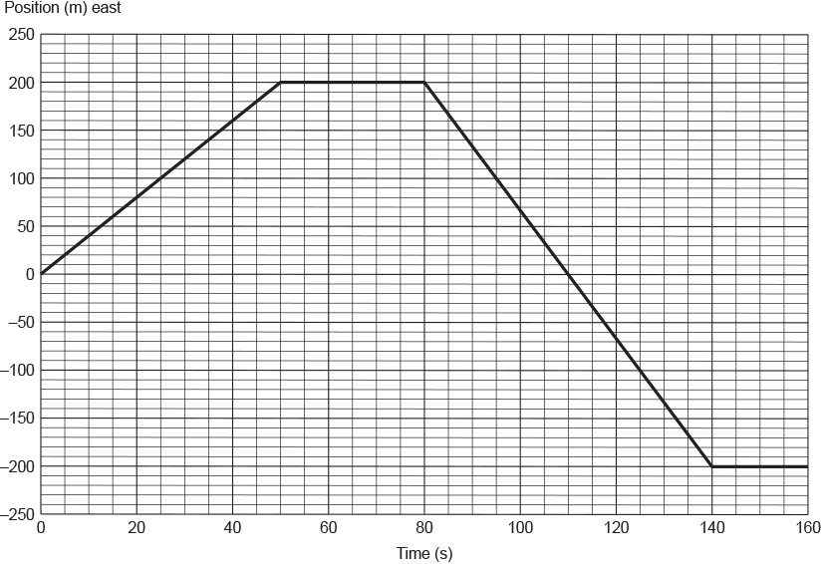

2 Describe the girl's motion as indicated by each of the different sections on the graph.

From t = 0 s to t = 50 s, the girl travelled a distance of 200 m at a constant speed.

From t = 50 s to t = 80 s, the girl is stationary.

From t = 80 s to t = 140 s, the girl travelled at a constant speed but in the opposite direction to that of her initial motion. At t = 110 s, she passed her starting point. She travelled a total distance of 400 m during this time interval.

From t = 140 s to t = 160 s, the girl was stationary.

3 How far did the girl travel in 160 seconds? Give your answer in metres.

In 160 s, the girl travelled a total distance of 200 + 400 = 600 m.

4 What was the girl’s displacement at each of the following times?

a t = 50 seconds

200 m

b t = 110 seconds

0 m

c t = 150 seconds

–200 m

5 What does the shape of the graph between t = 0 and t = 50 seconds suggest about the girl’s motion? Explain your answer.

Between t = 0 s and t = 50 s, the distance travelled increases by the same amount each second. This indicates that she was travelling at a constant speed.

A brother and sister arrived with their parents at a hotel that, below the foyer on the ground floor, had three levels of underground car parking. Above the foyer were 12 floors of guest rooms. While their parents were checking the family into the hotel, the two siblings snuck off to ‘ride’ in one of the lifts. From the hotel foyer, they rode the lift up 9 floors, then down 11 floors, up 5 floors and finally down 5 floors.

6 On which floor did the two siblings finish their elevator ride?

The brother and sister finished their elevator ride back on the second car park level, two floors below the ground floor.

7 How many floors did they pass through on their journey?

On their journey, the two siblings passed through 30 floors.

Extend your understanding

From a campsite, a hiker walked 12 kilometres north and 5 kilometres west. She then walked 4 kilometres south and 20 kilometres east.

8 In the space provided below, carefully draw the journey taken by the hiker. Use a scale of 0.5 centimetre = 1.0 kilometre. Draw a line from the hiker’s campsite to where her journey finished.

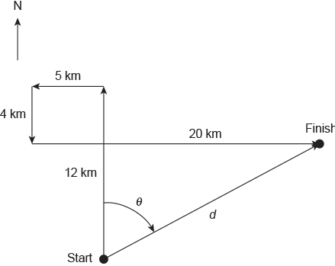

9 Without using a ruler or protractor, determine the hiker’s final displacement.

Answer:

17 km N 62o E

17 km 62o T

Student worksheet answers

7.2 Velocity is speed with direction

Pages 158–159

Speed and velocity

1 Explain in your own words, the difference between speed and velocity.

Speed is a scalar quantity that measures the distance travelled in a set time. Velocity, however, is a vector quantity and it measures the charge in displacement over time.

2 Use the formula triangle to identify the following formulas.

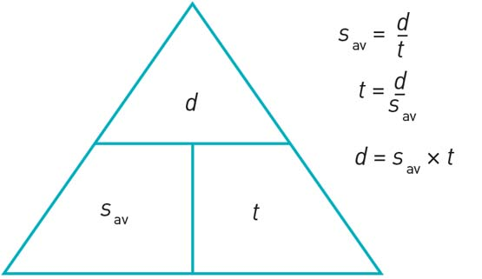

a Distance

Average speed multiplied by time

b Time

Distance divided by average speed

c Average speed

Distance divided by time

3 Use the formula triangle to identify the following formulas.

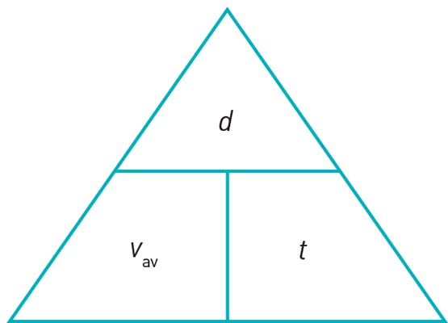

a Displacement

Average speed multiplied by time

b Time

Displacement divided by average velocity

c Average velocity

Displacement divided by time

4 In 2009 Usain Bolt set a new world record time of 9.58 seconds for the men’s 100 metres. What was his average speed for the race? Give your answer in metres per second.

sav = d/t

= 100/9.58

= 10.4 m s–1

5 Kenyan athlete Daniel Komen holds the world record for the men’s 3000 metres. If his average speed for the race was 6.81 m s–1, what is his world record time? Give your answer in minutes and seconds.

t = d/sav

= 3000/6.81

= 440.53 s

= 7 min 20.53 s

6 What was the total distance travelled by an object whose velocity–time graph is shown below? Give your answer in metres.

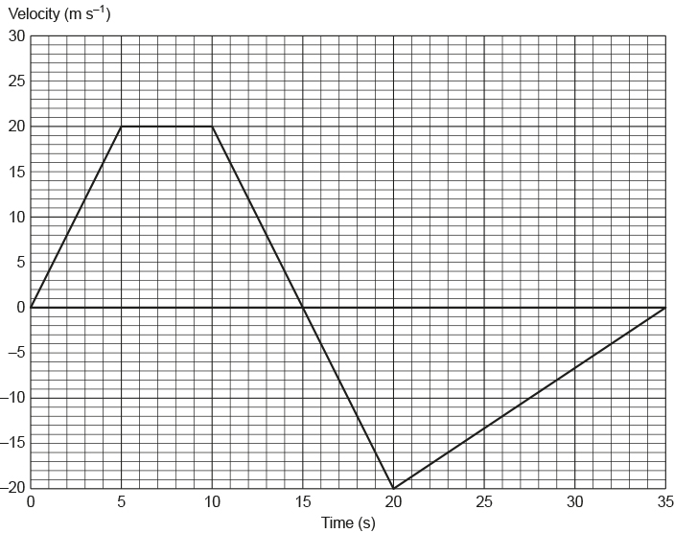

The total distance travelled by the object in 35 s will be equal to the ‘unsigned’ area underneath its velocity against time graph.

In this instance, that will be equal to the sum of the area of the trapezium outlined from t = 0 s to t = 15 s with that of the triangle formed from t = 15 s to t = 35 s.

7 What was the average speed of an object whose velocity–time graph is shown in Figure 3? Give your answer in metres per second.

sav = d/t

= 400/35

= 11.4 m s–1

8 What was the final displacement of the object after 35 seconds? Give your answer in metres.

The object’s final displacement after 35 s will be equal to the ‘signed’ area underneath its velocity against time graph.

In this instance, that will be equal to the signed sum of the area of the trapezium outlined from t = 0 s to t = 15 s with that of the triangle formed from t = 15 s to t = 35 s.

9 What was the object's average velocity during the 35 seconds?

vav = d/t

= 0/35

= 0 m s–1

Extend your understanding

This graph shows the motion of a man riding on a Segway along straight pathway.

|  |  |
| --- | --- |
| L:\1. Publishing and Editorial\1. Product\Oxford Science\Oxford Science 10\3. Extras\6. Student worksheets\Artwork\4. Final jpgs\SW0706_01095.jpg | L:\1. Publishing and Editorial\1. Product\Oxford Science\Oxford Science 10\3. Extras\6. Student worksheets\Artwork\4. Final jpgs\SW0707_01095-rf.jpg |

10 Which of the options, P–S, correctly describes the man’s motion in each of the stages AB, BC, CD and DE, as shown by the graph?

|  |  |  |  |  |
| --- | --- | --- | --- | --- |
|  | AB | BC | CD | DE |
| P | Decelerating | Constant speed | Accelerating | Stationary |
| Q | Accelerating | Stationary | Constant speed | Decelerating |
| R | Accelerating | Constant speed | Decelerating | Stationary |
| S | Decelerating | Stationary | Constant speed | Accelerating |

In section AB the gradient of the graph is increasing. This means that the Segway’s velocity is increasing – this means that it is accelerating.

In section BC the gradient of the graph is constant. This means that the Segway is travelling with a constant speed.

In section CD the gradient of the graph is decreasing. This means that the Segway’s velocity is decreasing – this means that it is decelerating.

In section DE the gradient of the graph is zero. This means that the Segway's velocity is zero – this means that it is stationary.

Option R correctly describes the Segway’s motion.

11 What was the man’s average speed during section AB? Give your answer in metres per second.

sav = d/t

= 20/4

= 5.0 m s–1

12 What was the man’s speed during section BC? Give your answer in metres per second.

sav = (200 – 20)/(17 – 5)

= 1800/12

= 15 m s–1

Student worksheet answers

7.3 Acceleration is change in velocity over time

Pages 160–161

Acceleration – speeding up and slowing down

1 What is acceleration?

Acceleration is the rate of change of speed.

2 Imagine that a marble is rolling along a table. List two ways that you could:



a change its speed but not its direction

Students’ answers will vary, but they could include: increasing the gradient or slope, using a fan to push the marble and so on.

b change its direction but not its speed.

Students’ answers will vary, but they could include: using a pre-made track, using a straw to blow the marble in a certain direction and so on.

3 The speed–time graph below shows an object travelling at constant speed before decelerating. In the space provided, draw another speed–time graph that shows an object accelerating before beginning to travel at a constant speed.

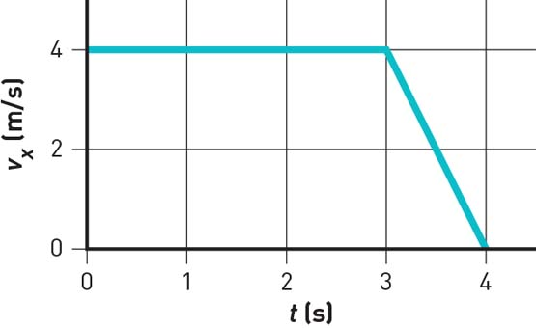

Students’ answers will vary based on the times they have chosen, but they should show a line with a steep gradient, which becomes a horizontal line further along the x-axis.

4 What is the average acceleration of a car that, from rest, reaches a speed of 27.8 m s–1 (100 km h–1) in a time of 4.6 seconds? Give your answer in metres per second per second.

, , ,

= 6.0 m s–2

5 What would be the final speed of a car initially travelling at 72 km h–1 if it accelerated at 1.25 m s–2 for 4.0 s? Give your answer in kilometres per hour.

, , ,

Extend your understanding

The graph below shows a journey made by a tram as it travelled along a straight stretch of track. The mass of the tram and its occupants is 25 000 kg.

|  |  |
| --- | --- |
| L:\1. Publishing and Editorial\1. Product\Oxford Science\Oxford Science 10\3. Extras\6. Student worksheets\Artwork\4. Final jpgs\SW0711_01095.jpg | L:\1. Publishing and Editorial\1. Product\Oxford Science\Oxford Science 10\3. Extras\6. Student worksheets\Artwork\4. Final jpgs\SW0710_01095-r.jpg |

6 What was the tram’s acceleration at t = 20 seconds? Give your answer in metres per second per second.

, , ,

7 What was the tram’s acceleration at t = 140 seconds? Give your answer in metres per second per second.

, , ,

= 0.80 m s–2

8 How far did the tram travel in the 150-second interval? Give your answer in metres.

=

Student worksheet answers

7.4 An object in motion remains in motion until a force acts on it

Pages 162–163

Newton’s first law: Inertia

1 Which of the two shopping trolleys shown in the diagram below has the greatest inertia? Explain your answer.



The shopping trolley full of groceries has a greater inertia than the empty trolley because the full trolley has a greater mass.

2 The diagram below shows a stack of five coloured circular disks made of smooth, polished wood. Describe the motion of the coloured disks when the plunger is hit quickly and firmly by the hand.

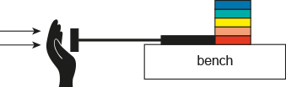

Due to the law of inertia, objects at rest will stay at rest until acted upon by an unbalanced force. In this instance, the plunger will provide an unbalanced force on the red disk pushing it to the right. The other disks will sit on top of the plunger without having moved forward.

3 The photograph below shows a 4.0-kilogram penguin sliding across a large, flat icy surface with a constant velocity of 2.0 m s–1. Assuming that the surface is frictionless, what size force is required to keep the penguin travelling at this speed?

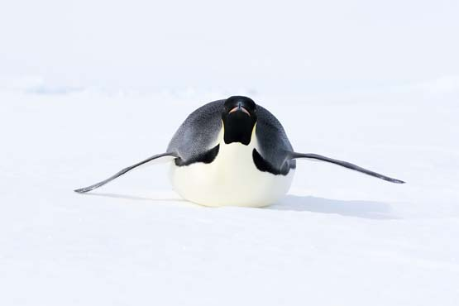

Given that there is no friction acting against the penguin’s motion, there is no need for any additional force to be applied to the penguin to keep it moving. It will continue to move across the ice in the same direction at 2.0 m s–1.

This is because of the law of inertia, which states that an object will travel with a constant velocity (speed and direction) until it is acted upon by unbalanced force.4 In the diagram below, will the cyclist be travelling in a state of constant motion? Explain your answer.

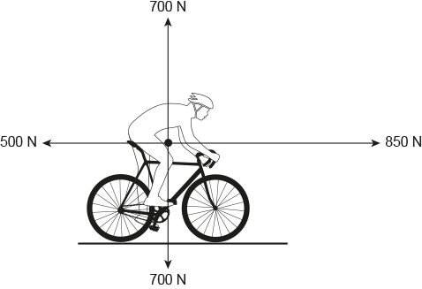

The cyclist in the diagram is not in a state of constant motion. This is because the forces acting on him are unbalanced. Horizontally the net force acting on the cyclist is 850 N – 500 N = 350 N to the right. So the cyclist will accelerate (increase velocity) in this direction.

Extend your understanding

5 Use your understanding of Newton’s law of inertia to explain how the cyclist got to the position he is in in the following photograph.

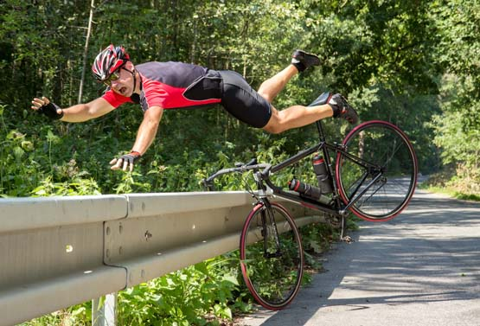

In the situation shown, the bike and its rider have collided with the safety barrier. The safety barrier has stopped the bicycle. However, it did not stop the cyclist and, due to his inertia, he has continued to travel forward beyond his bike and over the safety barrier.

6 Michaela took a ride on an amusement park ride called the ‘Space Shot’. At ground level at the start of the ride, Michaela said that she felt like she was being pushed very hard downwards into her seat – but that this confused her as she knew that she was moving upwards very quickly. Explain the physics of what Michaela experienced at the start of the ride.

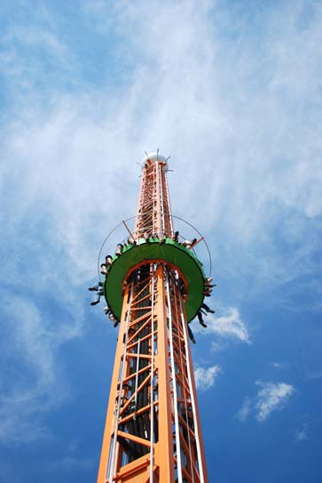

Initially, Michaela was at rest on the seat. Due to her inertia, her body ‘wants’ to remain at rest. When the ride starts and the seats accelerate upwards, Michaela’s seat pushes and accelerates her upwards. According to Newton’s third law, Michaela will push back her seat with the same amount of force that it is pushing her with – this is what is causing Michaela to feel as if she is being pushed very hard back into her seat.

Student worksheet answers

7.5 Force equals mass × acceleration

Pages 164–165

Newton's second law: Fnet = ma

1 Describe Newton’s second law.

Students’ answers should include that the acceleration of an object is directly related to the size and direction of the force acting on the object. The second law also introduces the formula of force equals mass multiplied by acceleration (F = ma).

2 What is the difference between mass and weight?

Mass refers to the amount of matter an object has while weight is the force of gravity acting on an object.

3 What formula can be used to calculate net force?

Net force (Fnet) = mass (m) × acceleration (a)

4 Complete the equation triangle for net force below and describe how it works.

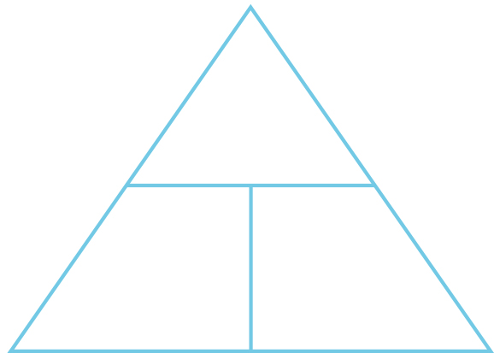

To use the triangle, students need to cover the quantity they wish to calculate. The remaining two quantities will form the formula.

Where necessary below, use g = 9.80 m s–2. Unit conversions: 1000 grams = 1 kilogram and 1000 kilograms = 1 tonne.

5 How much horizontal net force is required to accelerate a 1200-kg car at 1.5 m s–2?

,

6 A net force of 16 N gives a bowling ball an initial acceleration of 2.5 m s–2. What is the mass of the bowling ball?

, ,

7 A speed skater has a mass of 64 kg. She is providing a driving force of 400 N, and there is a frictional force of 240 N against her. Draw these two forces acting on her and then determine her acceleration.

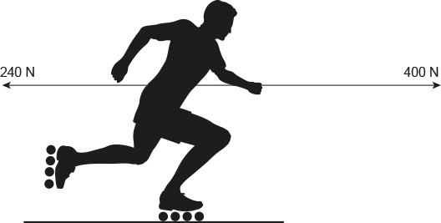

, ,

Extend your understanding

8 A skydiver of mass 85 kg is falling through the air at terminal velocity (constant speed).

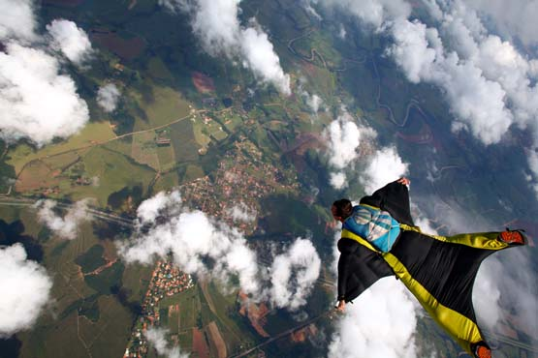

a What is the weight force acting on the skydiver?

, ,

b How much air resistance is acting on the skydiver?

At terminal velocity the skydiver is falling at a constant speed. This means that his acceleration is zero and hence the net force is also zero.

The two forces acting on the skydiver are weight (acting down) and air resistance (acting up), and these two forces are equal in size and opposite in direction.

This means that force of air resistance acting on the skydiver must be equal to 833 N.

9 The Airbus A380 has a mass at take-off of 575 tonnes. During take-off, its four engines provide a total thrust of 1300 kN. Its take-off speed is 270 km h–1 and it takes 72 seconds from rest to reach this speed.

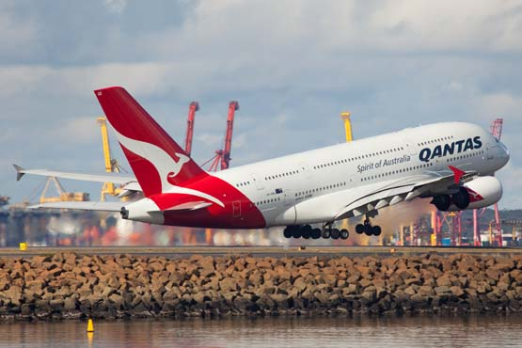

a What is the average acceleration of the A380 during its take-off run? Give your answer correct to two decimal places.

, ,

b What is the average total resistive force acting against the A380 during its take-off run?

From part a, ; and m =

Student worksheet answers

7.6 Each action has an equal and opposite reaction

Pages 166–167

Newton’s third law: FAB = –FBA

For each of the following four situations, describe the action and reaction forces. Remember that each force acts on a different item in the object pair.

Note: In all instances, although not stated in the answers, the reaction force is of the same size (magnitude) as the action force.

|  |  |  |  |
| --- | --- | --- | --- |
|  | Situation | Action | Reaction |
| a | A rocket taking off from its launch pad.  SW0723_01095-r | The action force is the rocket engine pushing out the hot exhaust gases. | The reaction force is the hot exhaust gases pushing the rocket upwards. |
| b | A tennis racquet hitting a tennis ball.  SW0724_01095-r | The action force is the tennis racket hitting the tennis ball. | The reaction force is the tennis ball pushing back on the tennis racket. |
| c | A sprinter pushing off from the starting blocks.  SW0725_01095-r | The action force is the sprinter’s feet pushing against the starting blocks (ground). | The reaction force is the starting blocks (ground) pushing back on the sprinter. |
| d | A footballer marking a football.  SW0726_01095-rf | The action force is the footballer’s two hands pushing against the football. | The reaction force is the football pushing back on the footballer’s two hands. |

Extend your understanding

6 A horse is pulling on a cart. If the cart exerts an equal and opposite force on the horse, how is it possible for the horse to pull the cart so that it moves? Use your understanding of Newton’s laws of motion to explain this situation.

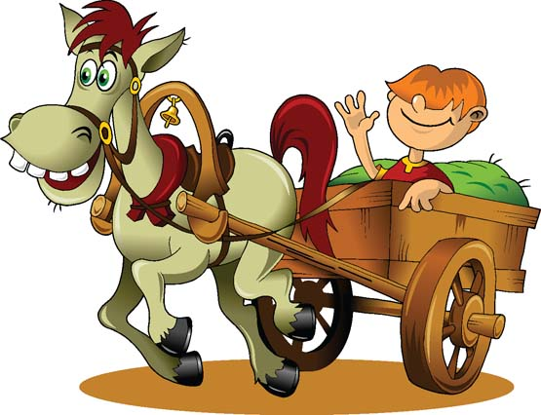

The cart does exert an equal and opposite force on the horse to that exerted by the horse on the cart. However, this action and reaction pair of forces doesn’t contribute to their motion.

Instead, you need to think about how a horse without a cart moves forwards. This is achieved in the same manner as how we are able to walk or run.

The action force is provided by the horse’s hooves pushing backwards against the ground. So, according to Newton’s third law, the reaction force will be the ground pushing the horse’s hooves, and hence the horse itself, forwards.

7 The photograph below shows a stationary gymnast hanging from a set of rings. What is the reaction force to the action of the weight force acting on the gymnast? Explain your answer.

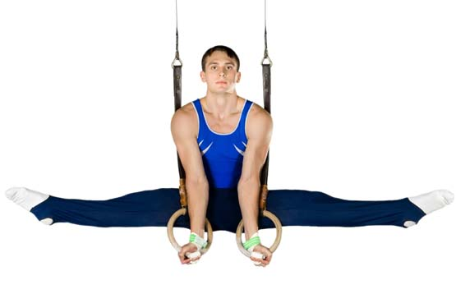

The weight force acting on the gymnast is the action force and is provided by the gravitational force that the Earth exerts on the gymnast.

So, according Newton’s third law, the reaction force must be the gravitational force that the gymnast exerts on the Earth.

Remember that both of these forces are equal in size to each other, but they act in opposite directions.

Student worksheet answers

7.7 Momentum is conserved in a collision

Pages 168–169

Momentum

1 What is the law of conservation of momentum?

Students’ answers may vary, but they should include that in an isolated system the total momentum does not change during a collision.

2 Consider the image below of Newton’s cradle. When a ball from the left is lifted and then dropped, the collision will force a ball on the other side to rise. Using the law of conservation of momentum, explain why this is happening.



When one ball is moved, its momentum gets passed down to the ball on the opposite side, which then starts moving with the same momentum. Each time it strikes the balls, the momentum is transferred again.

3 What is the formula used to calculate momentum?

Momentum (p) = mass (m) × velocity (v)

4 For each of the following situations, calculate the size of the object’s momentum.

a A speed skater of mass 75 kg moving with a velocity of 5.8 m s–1

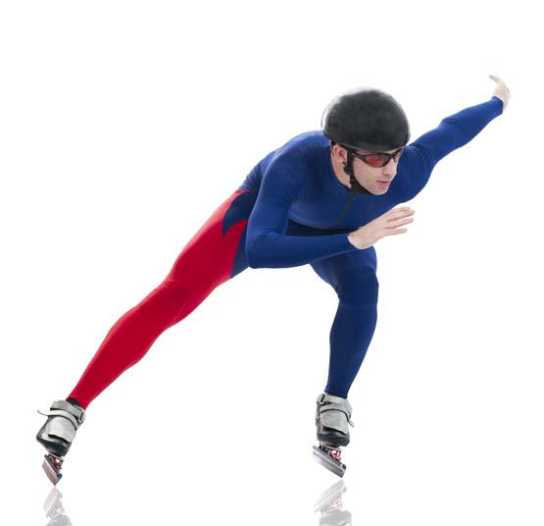

, ,

b A tennis ball of mass 58 g travelling at 180 km h–1



, ,

Extend your understanding

5 Jane and Christopher are performing a skating routine. Jane has a mass of 56 kg and Christopher has a mass of 84 kg. Before they collide, they are gliding along the ice in a straight line towards each other as shown in the 'Before collision' diagrams. After their collision, they move off together as shown in the 'After collision' diagram.

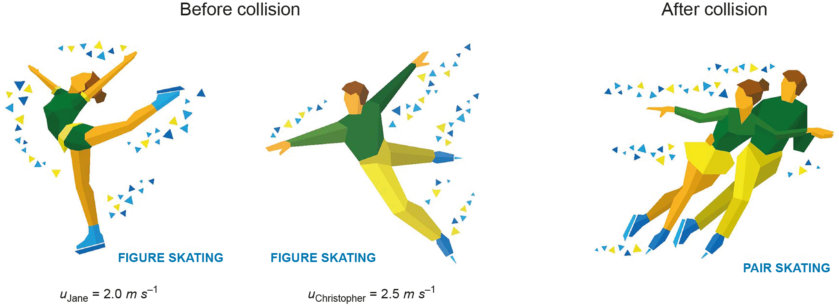

Use the principal of conservation of momentum to determine Jane and Christopher's velocity after their collision. (Velocity is a vector quanity, so remember to take this into account when performing your calculations!)

According to the law of conservation of momentum:

Before collision (pJane + pChristopher) = after collision (pJane + pChristopher)

Take ‘to the right’ as being in the positive direction, so any velocities to the left would be negative:

Student worksheet answers

7.8 Work occurs when an object is moved or rearranged. Energy can be calculated

Pages 170–171

Work, kinetic energy, gravitational potential energy and elastic potential energy

1 Complete the table by defining the key terms.

|  |  |
| --- | --- |
| Term | Definition |
| Work | Occurs whenever an object is moved by a force |
| Kinetic energy | The energy possessed by moving objects |
| Gravitational potential energy | The energy possessed by objects raised to a height in a gravitational field |
| Elastic potential energy | The energy possessed by stretched or compressed objects |

2 Complete the flow chart below that shows the energy transformations (work) for a bouncy ball falling to the ground and bouncing back up again. Where necessary, use g = 9.80 m s–2. Converting units: 1000 joules (J) = 1 kilojoule (kJ).



3 How much work has to be been done on a stationary car of mass 1800 kg to get it travelling at a speed of 110 km h–1?

A 0 J

B 2.8 × 104 J

C 9.9 × 104 J

D 8.4 × 105 J

E 1.1 × 107 J

,

Hence, D is the correct answer.

4 Without changing its mass, what effect will decreasing an object’s speed from 15.0 m s–1 to 5.0 m s–1 have on its kinetic energy?

A Its kinetic energy will remain unchanged.

B Its kinetic energy will be a third of what it was initially.

C Its kinetic energy will decrease by a factor of nine.

D Its kinetic energy will increase by a factor of nine.

E Its change in kinetic energy cannot be determined from the information provided.

, ,

Hence, C is the correct answer.

5How much gravitational potential energy does a 250-g kite have if it is hovering 30 m above the ground?

A 0 J

B 73.5 J

C 735 J

D 73.5 kJ

E 73 500 kJ

,,

Hence, B is the correct answer.

Extend your understanding

6 Figure 2 shows a toy gun. Inside the gun, there is a spring that is compressed a total distance of 5.0 cm by pushing a suction-capped dart into its barrel. Figure 3 shows a graph of the spring’s force (N) against compression distance (m).

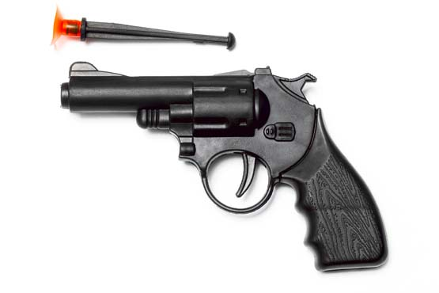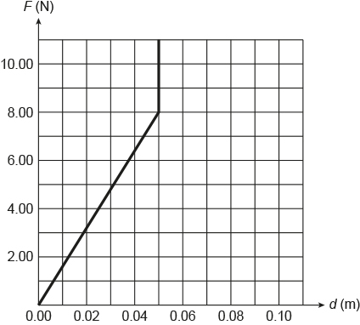

The energy stored in a spring can be determined by calculating the area underneath its force (N) against extension (m) graph.

How much energy is stored in the spring when it is compressed by 5.0 cm?

The energy stored in the spring will be equal to the area underneath its force (N) against extension (m) graph.

Student worksheet answers

7.9 Energy is always conserved

Pages 172–173

Conservation of energy

1 What is the law of conservation of energy?

Energy is always conserved.

2 Which two types of energy are harnessed by a pendulum?

Gravitational potential energy and kinetic energy

A student of mass 60.0 kg went bungee jumping during her holidays. The bridge from which she jumped was 250 m above a river. She was attached to a bungee cord that had an unstretched length of 150 m. You can assume that the student and the bungee cord are part of an ideal energy-conversion system. This means that no energy is 'lost' to the environment as heat or sound.

Figure A shows the student just before she jumps off the bridge.

Figure B shows the student a short time later when she has fallen a distance equal to the unstretched length of the bungee cord.

And Figure C shows the student when the bungee cord has reached its maximum length and the student is momentarily stationary.

|  |  |  |
| --- | --- | --- |
| SW0739_01095 | SW0740_01095 | SW0741_01095 |
| **A** | **B** | **C** |

3 At which point is the bungee jumper likely to experience the most kinetic energy?

B

4 At which point is the bungee jumper likely to experience the most elastic energy?

C

5 What was the student’s gravitational potential energy at point A as shown in Figure 1? Provide your answer in joules. (Remember: GPE = mass × gravity × height)

m, ,

Note: At point A, the bungee cord is not stretched, so there is no elastic potential energy and because the bungee jumper is not moving, there is no kinetic energy. So the bungee jumper’s total energy will be 147 000 J.

6 How much elastic potential energy is stored in the bungee cord when the student has fallen 180 m and reached point C as shown in Figure 3? Give your answer in joules.

At point C, the bungee jumper’s total energy will still be 147 000 J. As the bungee cord has now stretched and the bungee jumper is stationary, the bungee jumper has gravitational potential energy and elastic potential energy.

, , ,

Extend your understanding

A pendulum, as shown in Figure 1, is known to have an efficiency of 95% on each swing.

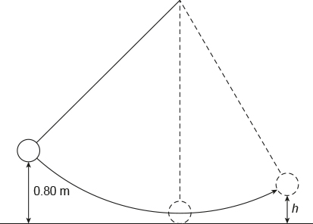

Figure 1

7 To what height, h, would the pendulum bob rise after a single swing if it was being released from a height of 0.80 m as shown? Give your answer in metres.

8 How far below its release height of 0.80 m would the pendulum bob be after its return swing? Give your answer in metres.

Student worksheet answers

7.10 Car safety features requires an understanding of Newton's laws and momentum

Pages 174–175

Newton's laws and car safety features

While out driving in his car, Harry went around a corner too quickly, lost control of his car and ran off the road, colliding with a tree. His friend Ash was beside him in the passenger seat. Both men were wearing seatbelts. The car was travelling at a speed of 54 km h–1 when it hit the tree.

Unfortunately, Ash’s airbag malfunctioned and did not deploy while Harry’s airbag did deploy. Because of this, the time for each of their heads to come to a stop was different. Ash’s head collided with the dashboard and took 0.012 s to come to a stop. Harry’s head collided with the airbag and took 0.060 s to come to a stop.

The mass of Harry’s head was 5.0 kg, the same as Ash’s head.

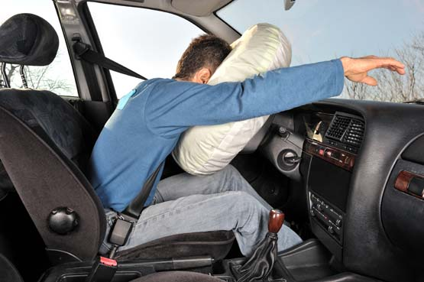

1 What safety features were supposedly in place in Harry’s car?

Seatbelts and airbags

2 How does an airbag work?

A chemical reaction involving nitrogen gas causes the airbag to inflate during an accident. Airbags are designed to increase the length of time the driver has to decelerate, which decreases the amount of force exerted by the steering wheel.

3 Describe one other safety feature that might have helped to keep Harry and Ash safe?

Crumple zones are designed to crush during a collision and give the car more time to decelerate.

4 What was the initial speed of each man’s head at the start of the collision? Give your answer in metres per second.

5 Calculate the acceleration experienced by Harry’s head and that of Ash during their respective collisions. Give your answer in metres per second per second to the nearest whole number.

|  |  |
| --- | --- |
| Harry  , , | Ash  , , |

6 Calculate the average force experienced by each of Harry and Ash's heads during their respective collisions. Give your answer in newtons to the nearest whole number.

The negative sign in these answers indicates that the stopping force is acting in the opposite direction to that in which Harry’s and Ash’s heads were initially travelling before colliding with the airbag or dashboard.

|  |  |
| --- | --- |
| Harry  , | Ash  , , |

7 Based upon your calculations, what conclusions can be drawn about the relationship between the average stopping force on an object and the collision time?

The results of the calculations in questions 5 and 6 show that if the collision time is increased (in this case, by a factor of five), then the stopping force required will be reduced (in this case, by a factor of five). Increasing the collision time reduces the magnitude of the stopping force experienced by the occupants of a car, reducing the chance of them experiencing serious or lethal injuries.

However, it should be noted that if a car is travelling at high speed and is involved in a collision, then its occupants are at great risk of suffering serious or lethal injuries.Extend your understanding

8 Use your understanding of Newton’s three laws to describe the motion of, and the forces acting upon, Harry’s head during the car’s collision with the tree.

As the tree pushes against the car and slows it down, Harry’s body, due to the law of inertia, will continue to move forwards at 54 km h–1.

If he was wearing his seatbelt, it would push him back into his seat, effectively slowing him down at the same rate as the car was being slowed down by the tree.

However, the seatbelt will not stop his head from continuing to move forwards due to its inertia. While Harry's head moves forwards, the airbag is inflated. It is designed to be fully inflated by the time his head reaches it. The airbag has holes in it so that when Harry’s head pushes against it, gas is forced out of the bag. According to Newton’s third law, the airbag will pushed back against Harry’s head with the same amount of force. The airbag increases the collision or stopping time for Harry’s head; therefore, as shown previously in questions 5 and 6, Harry’s head will experience a smaller stopping force than if it collided with the car's steering wheel, windscreen or dashboard.

The acceleration experienced by Harry’s head will be in the opposite direction to his head’s initial (forwards) direction of travel.

The force experienced by Harry’s head is directly related to the car's initial speed and how long the collision took according to Newton's second law.